EXPT NO:7 | IMPLEMENT ADVANCED CHART TYPES USING TABLEAU AND  POWER BI
DATE: 14.08.2026

PRE-LAB QUESTIONS (PROVIDE BRIEF ANSWERS TO THE FOLLOWING QUESTIONS)

- What is data integration in the context of Business Intelligence (BI)?
Data integration in Business Intelligence is the process of combining information from multiple data sources into a unified system for analysis. It allows data from sources such as CSV files Excel files and databases to be connected and analyzed together. In this experiment sales information and regional sales targets are integrated using the Region field. Data integration provides a more complete view of business performance and helps users compare actual results with planned targets for better analysis and decision making.

- Explain the difference between a join and a data blend in Tableau.
A join combines data from different tables using a common field and creates a combined table for analysis. A data blend connects separate data sources during visualization using a common linking field. Joins are generally used when datasets can be directly combined through matching fields while blending is useful when data comes from separate sources that cannot easily be joined. In this experiment Tableau can use a relationship or join based on the common Region field between the sales and target datasets.

- What are relationships and cardinality (e.g., one-to-many, many-to-many) in Power BI's data model?
Relationships define how tables are connected using a common field in Power BI. Cardinality describes how records in one table relate to records in another table. A one to many relationship means one record in one table can be related to multiple records in another table. A many to many relationship allows multiple records on both sides to match. In this experiment a many to one relationship is suitable because many sales transactions belong to one regional target.

- Why is data quality (e.g., consistent naming conventions, data types) crucial when integrating data from different sources?
Data quality is important because inconsistent values can prevent datasets from connecting correctly and can produce inaccurate results. For example if one dataset contains a region name such as N. America while another contains North America the relationship may fail to match the records. Similarly incorrect data types can affect calculations and filtering. Therefore the datasets should be cleaned before integration by standardizing names checking data types and handling missing values. This ensures reliable dashboard results.

- Name two common challenges encountered during data integration.
Two common challenges during data integration are mismatched field values and incorrect data types. Mismatched values can occur when the same region has different names or formats in different datasets. Incorrect data types can occur when numeric values are stored as text or dates are not recognized correctly. Missing values and differences in data granularity can also create problems during analysis. These challenges can be addressed through data cleaning standardization and validation before creating relationships between datasets.

IN-LAB EXERCISE:
OBJECTIVE:
To connect, combine, and model data from multiple sources in Tableau and Power BI and create a unified, comprehensive dashboard for holistic analysis.

PROCEDURE:
- Data Collection:
  - Import two datasets:
    - Dataset 1: Sales Data (CSV) → Order ID, Order Date, Region, Sales Amount
    - Dataset 2: Regional Sales Targets (Excel) → Region, Sales Target, Target Year
- Data Preparation and Transformation:
  - Clean datasets (e.g., standardize "N. America" → "North America"). • Ensure correct data types (numeric for Sales, date for Order Date).
  - Handle missing values appropriately.
- Data Integration and Modeling:
  - Tableau: Create a join/relationship on the Region field in the Data Source pane.
  - Power BI: Use the Model view to create a relationship on Region; define cardinality (e.g., many-to-one).
- Create Calculated Fields for Comparison:
  - Target Achievement % = (SUM(Sales) / SUM(Sales Target)) * 100
  - Sales vs. Target Variance = SUM(Sales) - SUM(Sales Target)
- Design a Comprehensive Dashboard:
  - Combine visuals from both sources.
  - Add KPI cards: Total Sales, Overall Target Achievement %.
  - Use gauge/bullet charts for region-wise target performance.
  - Combined bar chart: Actual Sales vs. Target by Region.
  - Map visualization: Sales vs. Target Variance by region.
- Validate Data Integrity:
  - Cross-check joined data for accuracy.
  - Ensure dashboard filters correctly update visuals.
- Publishing and Sharing:
  - Tableau: Publish to Tableau Public or Server.
  - Power BI: Publish to Power BI Service and share.
Experiment Datasets:
  - Dataset 1: Retail Sales Data (CSV) → Order ID, Order Date, Region, Sales
  - Dataset 2: Regional Sales Targets (Excel) → Region, Sales Target, Target Year

Screenshot of PowerBI
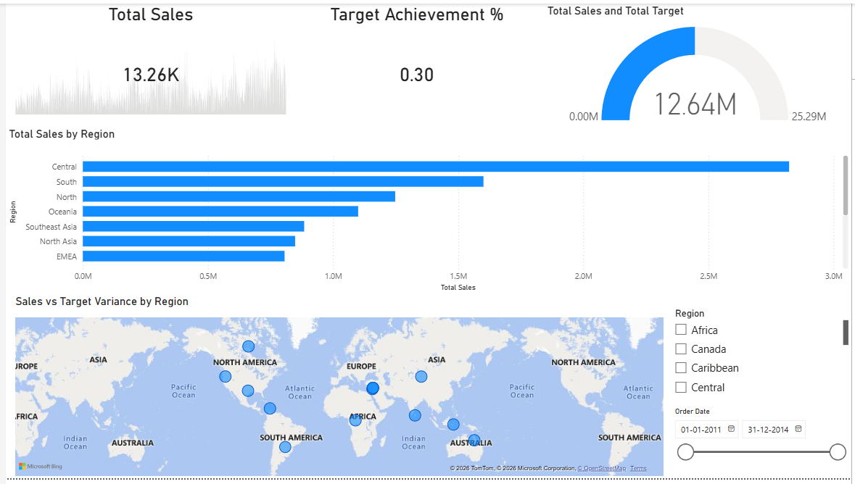

Screenshot of Tableau
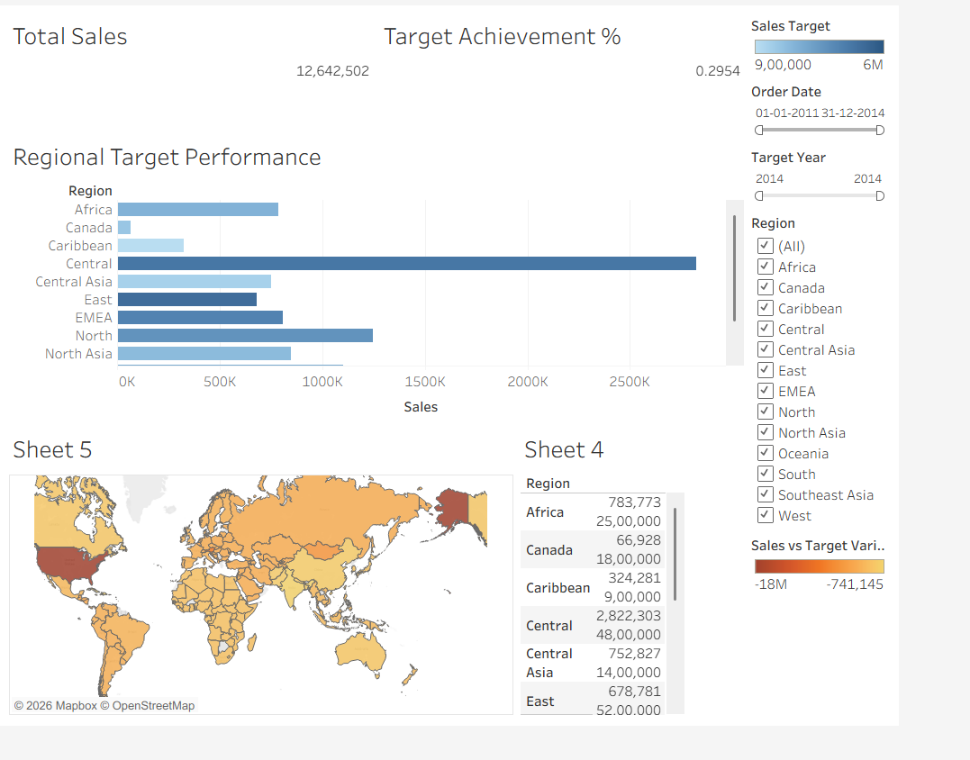

POST-LAB QUESTIONS (PROVIDE BRIEF ANSWERS TO THE FOLLOWING QUESTIONS)
- How did integrating the sales targets data provide a more complete analytical picture than using the sales data alone?
Integrating sales targets with actual sales data provided a more complete view of regional business performance. Sales data alone shows the amount of revenue generated but does not indicate whether the performance met the expected target. By connecting the regional target dataset we could calculate Target Achievement Percentage and Sales versus Target Variance. These calculations helped identify regions that exceeded their targets and regions that performed below expectations. Therefore the integrated dashboard provided more meaningful performance insights than using sales data alone.

- Describe the type of join or relationship you used to combine the two datasets and explain why it was the appropriate choice.
The two datasets were connected using the common Region field. In Power BI a many to one relationship was used because the sales dataset contains multiple transaction records for each region while the regional target dataset contains target information for each region. This relationship allows sales information to connect with the corresponding target value without unnecessarily duplicating the target records. In Tableau the datasets can be related using the Region field which allows information from both sources to be used in the dashboard.

- What challenges, if any, did you face regarding data granularity or mismatched keys (e.g., different region names) between the two sources?
One possible challenge was the difference in data granularity between the two datasets. The sales dataset contains many individual transactions while the target dataset contains regional target values. Another challenge can occur when region names are not written consistently in both sources. For example N. America and North America would not match correctly without cleaning. To address these issues the region names should be standardized and the relationship should be created with the correct cardinality. Data types should also be checked before integration.

- How can creating variance calculations (e.g., Sales vs. Target) help a business manager make better decisions?
Sales versus Target Variance helps managers understand whether actual performance is above or below the planned target. The calculation is obtained by subtracting the target from actual sales. A positive variance indicates that sales exceeded the target while a negative variance indicates that sales were below the target. This information allows managers to identify strong and weak performing regions. They can then allocate resources more effectively and develop strategies to improve areas where performance is below expectations.

- What other data source (e.g., marketing campaign data, customer demographics) could you integrate to further enrich this analysis, and what new insights might it provide?
Marketing campaign data could be integrated with the sales and regional target datasets to provide deeper insights into business performance. The combined analysis could show whether specific marketing campaigns contributed to increased sales in particular regions. Customer demographic data could also be useful because it could reveal purchasing patterns among different customer groups. Inventory data would provide additional information about whether product availability affected sales. Integrating these sources would help managers understand the factors influencing sales performance and make better strategic decisions.

RESULT:

The retail sales and regional targets datasets were successfully connected, cleaned, and integrated in Tableau and Power BI. Relationships between the sources created a unified data model. The dashboard visualized sales performance against targets, enabling variance analysis and providing insights into regional performance not possible with a single data source.

ASSESSMENT

Description |  | Max Marks | Marks Awarded
Pre Lab Exercise |  | 5
In Lab Exercise |  | 10
Post Lab Exercise |  | 5
Viva |  | 10
 | Total | 30
 | Faculty Signature

